
Petal Power
GFWC Joppatowne Woman's Club, Inc.
P.O Box 382 Joppa, MD 21085-4502

January, 2013

President’s Message Diane Raycob
410-893-7534

Dear ladies,

Happy New Year to everyone! I hope everyone is having a peaceful and restful holiday.
Our December meeting was fun with singing, ornament exchanging (left and right), and good cheer.
This is the time for renewing our goals or setting new ones. Let’s continue to be focused on the few things we do for our community and each other. Let’s not try to do too many things, otherwise we may become diluted and lose value. Let’s stay diligent about maintaining our “foci.”
Be proactive in telling your president (me) what our priorities as a GFWC woman’s club should be. What would you like from this club?
There’s a lot of competition out there for our members time, energy, and resources. So, we must share the benefits of belonging to the Joppatowne Woman’s Club. It goes beyond the level of our local club. We need to connect with the marginal member, or someone with younger children, those who can’t drive at night, those with professional responsibilities, and the list goes on. GFWC is not the only organization experiencing a declining membership. Most institutions and organizations are. So, we need to be relevant to future generations. Let’s reach out for younger membership and continue to take care of our own.
Take time to spend this season and every day with your family and friends. They make our lives whole.

Take care,
Diane

Life is like a field of newly fallen snow. Where I choose to walk, every step will show. – Denis Waitley


Hospitality Madeleine Murphy
410-569-0477
Dinners are $20.00 except for Crab Cake & Prime Rib and they are prices at $25. Please call in your dinner order to one of the ladies listed below by noon on Tuesday. If you have to cancel, please do not call the restaurant. Call Madeleine.
Here are the January 10th dinners: Chicken Marsala, Flounder Francese, or Plain chicken.
Hostesses: Madeleine Murphy 410-569-0477 Jeanette Petnic 410-679-0959

January Birthdays
Betty Meidinger 11
Betty Manthei 26
Rose Marie Vaccaro 31
February Birthdays
Cathy Bowden 12
Ellie Kimlicko 22


First Vice President/Membership Lori Eck
443-484-2054

GFWC clubs recruited 1,105 new Federation sisters this fall! This is nearly three times as many members as were recruited during the summer months. Additionally, twice as many clubs reported their recruitment figures. For event ideas and tips, read the Membership Advancement Guide in the GFWC Club Manual. (You can see this online.) Remember we can submit our winter recruitment reports by March 1, 2013.

While gift wrapping at Boscov’s, our club was asked to hold a workshop in their auditorium. What a great way to recruit new members! On February 7th at 11 a.m., we will be able to speak to the community about the Joppatowne Woman’s club and the GFWC. Our president is hoping to possibly show a DVD about the international organization and hand out pamphlets about our group. If you can help out this day or have any ideas, please let Diane Raycob know.

Ruth Cameron is feeling much better. She has had a couple of hospital stays but is now home. She wants to let everyone know that she really appreciated the get well cards and all the prayers. She hopes to be back for the January meeting and is looking forward to seeing everyone. She is wishing everyone a very Merry Christmas and a Happy New Year.

Please keep Dee Ketelhut and her husband in your thoughts and prayers. Bob undergoes dialysis twice or three times a week. Claire Geis has also been under the weather. She is waiting for test results. Please give her a call or send her a note.

Ladies, I need you to do me a favor. I need you to save all your Christmas cards because I have a great project we can do for next Christmas and raise some money at the same time. Rose Marie Vaccaro will also be collecting Christmas Card FRONTS this year. (Perhaps you can save half for me and give the other half to her!)

I am currently looking into have a “friends and family” luncheon sometime in the spring for membership. Any suggestions are welcome.

Remember: Please contact me if you will have a possible new member/guest at one of our meetings.

New email address for Karen Conte: irishgrami@verizon.net . Please adjust your handbook.

See ya next year! Lori

Second Vice President/Programs Betty Manthei
410-679-4653

Our HOBY award recipient will be speaking to us at the January 10th general meeting. HOBY stands for Hugh O’Brien Youth. HOBY programs provide youth selected by their schools to participate in unique leadership training, service-learning and motivation-building experiences. HOBY also provides adults with opportunities to make a significant impact on the lives of youth by volunteering. Over 4,000 committed HOBY volunteers plan and execute the programs each year, serving both at the local HOBY affiliate level and on HOBY’s Board of Trustees. Due to the selfless efforts of volunteers and the contributions of generous donors, nearly 9,000 students participate in HOBY programs annually. Our club usually sponsors a sophomore from Joppatowne High School.

Arts
Members: Dottie Bishoff, Lori Eck, and Ellie Kimlicko

A group of us met at Lori’s home and we came up with a couple of ideas. We want to set up a booth at the local farmers’ market with JWC info. But, we can make it more enticing by selling a small craft item. We will make penholders/flower pots and sell them for a small price. Next to them will be our contact information and a list of things our club does.
Some of us are meeting January 12th at 12 p.m. at the Dollar Store to get materials for our artistic endeavor. Our next meeting is January 17 at 7 p.m. at Lori’s. You don’t have to be on the committee to help out and/or learn a new craft. This is going to be fun!


Conservation
Members: Dottie Bishoff, Maureen Cornett, Claire Geis and Carol Metzger
MORE TIPS
1. Put food coloring in you toilet tank. If it seeps into the toilet bowl without flushing, you have a leak. Fixing it can save up to 1,000 gallons a month.
2. When you have ice left in your cup from a take-out restaurant, don't throw it in the trash, dump it on a plant.
3. To save water and time consider brushing your teeth while in the shower.
4. Monitor your water bill for unusually high use. Your bill and water meter are tools that can help you discover leaks
5. Upgrade older toilets with water efficient models.
Ladies don't forget your pop-tops for Ronald McDonald house, and your items for the Humane Society.

Education Karen Conte & Barbara Ledford
410-569-3902 410-679-1166
Members: Barbara Albers, Dottie Bishoff, Cathy Bowden, Joyce Brown, Ruth Cameron, Dee Martin, and Rosemary Sebula

Everyone seems to be enjoying reading with their assigned children and I have wished mine “Adieu” for the Christmas holiday. She has become a good little reader. I will be leaving for N.C. this season.

And I wish everyone a very happy, healthy Christmas and New Year.

Home Life Barbara Albers & Sue Tyber
410-679-5260 410-679-8963
Members: Dottie Bishoff, Ruth Cameron, Reno Eitel, Ellie Kimlicko, Barbara Ledford, Betty Manthei, Dee Martin, Jeanette Petnic, Ursula Pierce, Rosemary Sebula, and Rose Marie Vaccaro
Brunch with Santa went great! We had 4 more children this year. Russ Brown stepped in at the last minute to play Santa for us, and he did a great job.
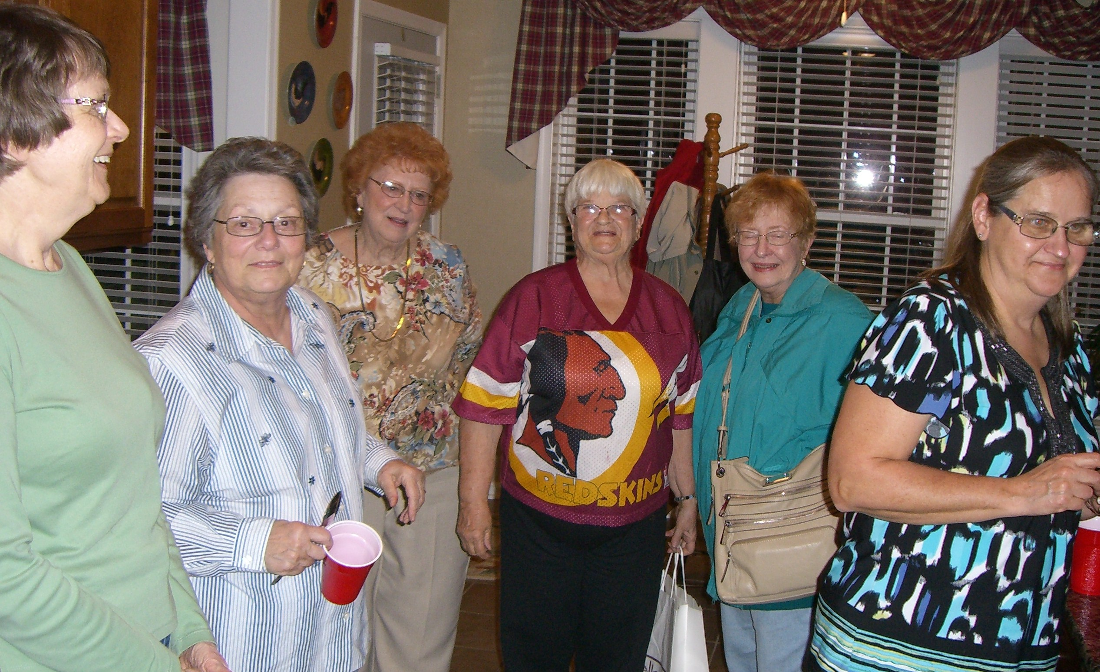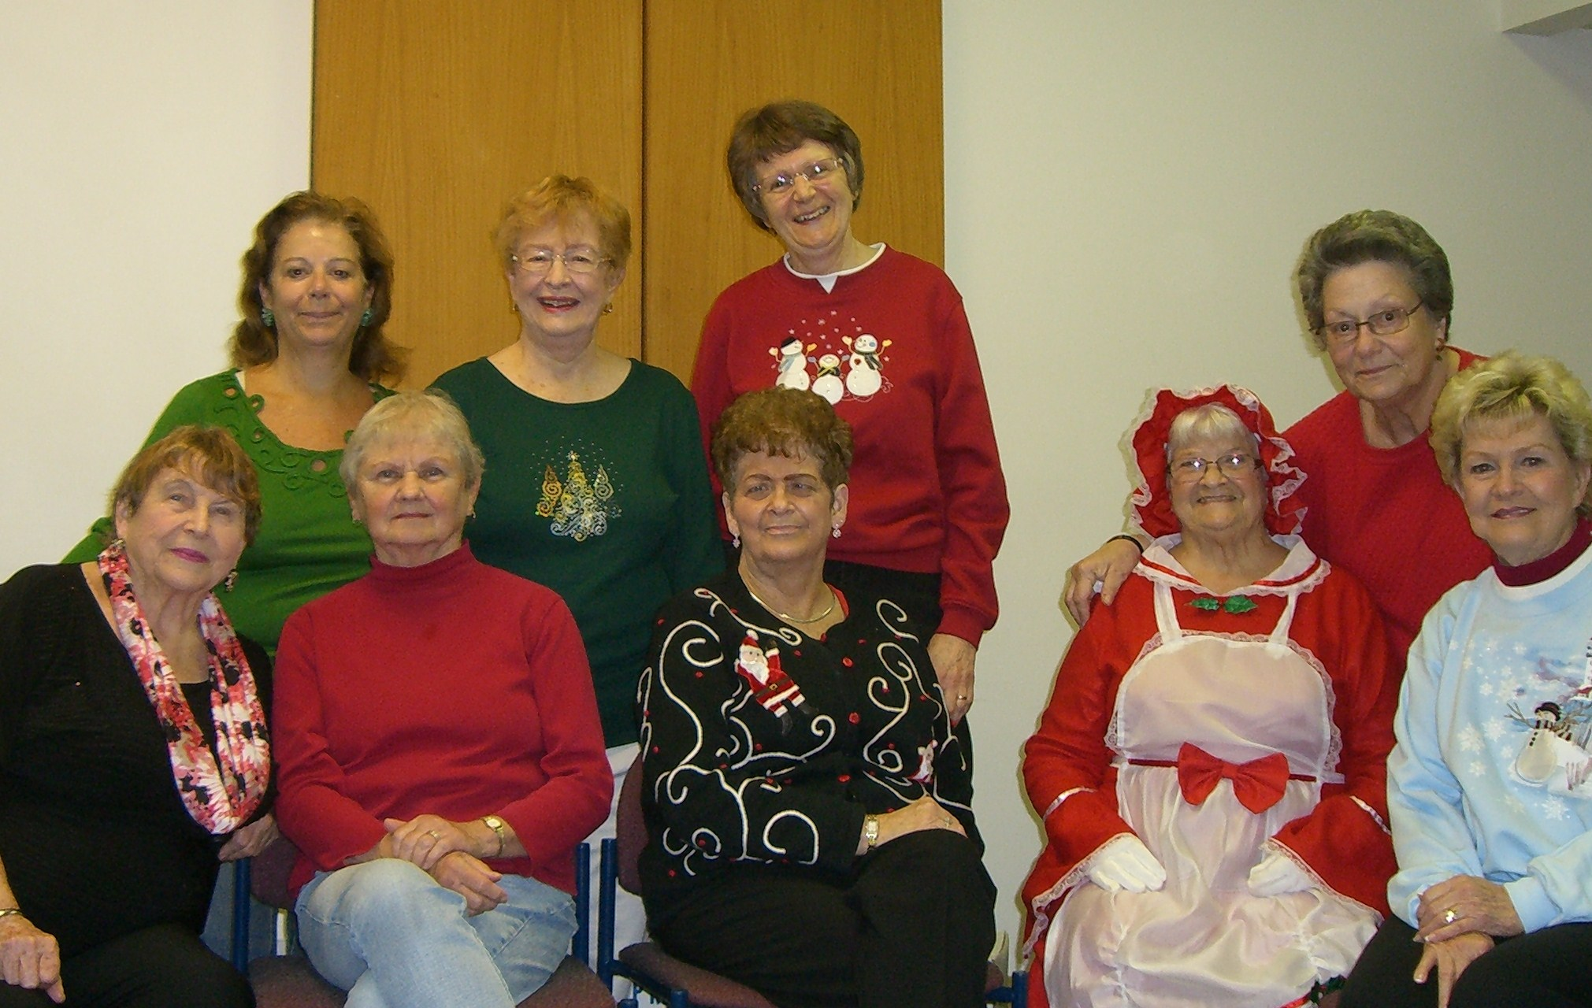
Busy Board Meeting Santa’s Helpers

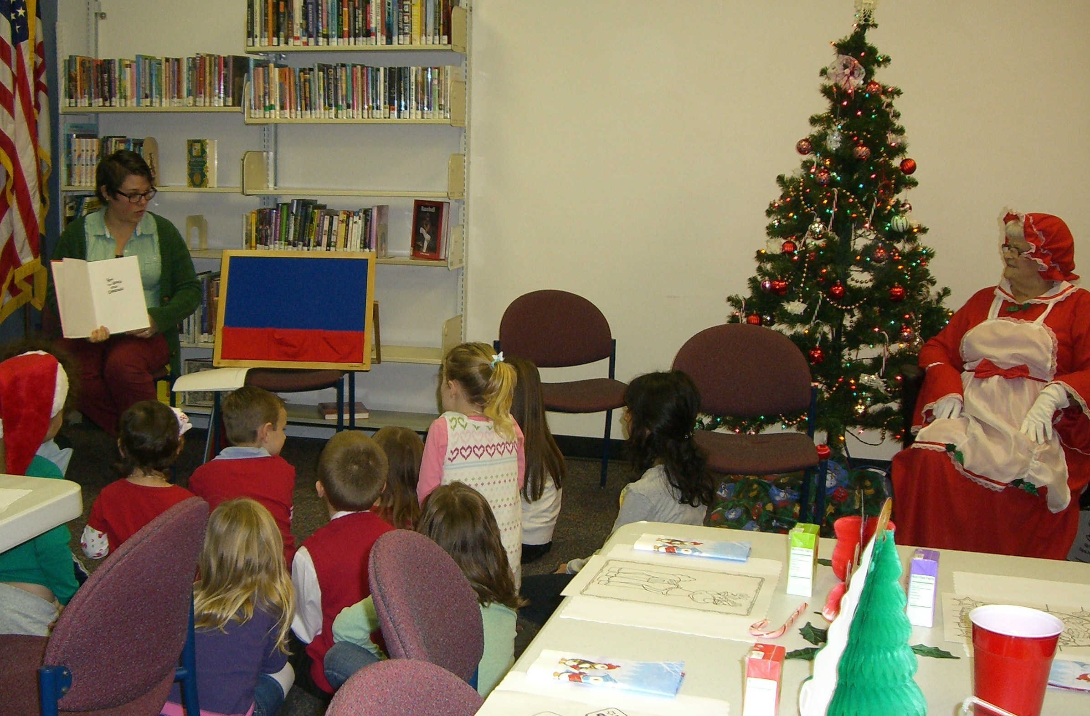
Children listening to a Christmas story
There will be a Home Life meeting on Friday, Jan. 4th at 2P.M. at my house (Barb A.). All members of this committee please mark your calendars. We will review what we’ve done so far this year, and make decisions on projects for the remainder of “our” year.
Health Information: Colon-rectal screening (colonoscopy) should be done every 10 years starting at age 50. (Consumer Reports)
International Outreach Mindy Kretschmer 410-638-5449
Members: Dottie Bishoff, Madeline Murphy, Mary Reynolds, and Rose Marie Vaccaro
Around the world there are 150 million orphans. 650,000 orphans live in Nepal itself. Many children in Nepal who have lost their parents are forced to work and become caretakers of their younger siblings. 13 year old Nirmala, an orphan is taking care of her younger siblings. Nirmala works long days to help provider much needed food for her brother and sister.
Hunger is a real problem in Nepal with half of all children suffering from malnutrition and affects the most vulnerable children like Nirmala and her siblings.
UNICEF is there in Nepal helping Nirmala and children like her realize their potential by providing special protection and diets and opportunities to attend school and get an education for a brighter future.
Big thanks to our heroes who Trick or Treated for UNICEF with a donation of $100.00!

Public Issues Barbara Knapp 410-679-4330
Members: Dottie Bishoff, Reno Eitel, Betty Manthei, and Betty Meidinger
Our Valentine's Day project for the Perry Point VA Medical Center is quickly approaching. Each club member is asked to make 2 homemade Valentine card and bring them to the January General Meeting for collection. The VA Medical Center has identified 50 veterans in one building who will be recipients of our valentines.
The Valentines should be no larger than 8"x10" so they can easily fit into a mailing envelope. Use your clever ideas and have fun making Valentine cards as you did when you were a child. I'm excited to see what everyone creates. Make your Valentine messages light-hearted so we can give our veterans chuckle. Betty Manthei will collect your cards and I will make sure they reach the Perry Point VA before Valentine's Day.
The Public Issues Program Committee will be meeting on Monday, February 4, 7 p.m. at Reno Eitel's home to discuss plans for the remainder of the club year. If you would like to join us, please give me a call at 410 679-4330.
We continue to collect used cell phones that are no longer needed. The phones will be taken to Exit Reality who will send them for repair and distribution to our military serving overseas.
Donations of used clothing and household items given to the Edgewood Thrift Store, Viet Nam Veterans of America, AM Vets and Purple Heart support our veterans. Please report the dollar amount of your donation to our program and we'll track these donations in our contributions to the community.


Ways & Means Dottie BISHOFF 443-402-1421
Members: Barbara Albers, Cathy Bowden, Joyce Brown, Karen Conte, Reno Eitel, Claire Geis, Barbara Ledford, Betty Manthei, Betty Meidinger, Madeleine Murphy, Jeanette Petnic and Rose Marie Vaccaro
Thanks to all you ladies for making the Kindle Fire raffle such a success. The lucky winner was club member Karen Conte. The total collected from the Kindle Fire raffle was $667.00.
Karen was also in charge of our fundraiser with Boscov's. Several of our club members went to Boscov's on Wednesdays, wrapping Christmas gifts for their customers. The wrapping was free and we got to keep all donations (tips) for the club. We received donations totaling $401.15 for the 4 days of work to put towards our fundraising. Next year we plan to start earlier in the season. These two December fundraisers give us a total of $1,068.15 towards our budget goal.
Most of you have your "Pot of Gold" tickets, as with the raffle tickets. Checks are to be made out to JWC. I will get the tickets to our members who were not at our December general meeting.
I will have tickets for the tea at the January meeting. I will have 150 tickets, so let me know how many tickets you will need. Other GFWC clubs have been asking me about the tea, and when can they purchase tickets. There will be seating for 10 at a table. Cost of tickets will be $27.00 per person. The date of the tea is May 4th at the Richlin Ballroom, in Edgewood, MD.
Don't forget to give Rose Marie Vaccaro your Redner's tapes.
Dates to Remember
January 4 – Home Life Meeting – Barbara A.’s, 2 p.m. January 8 – Art members meet at the Dollar Store, 12 p.m. January 10 – General meeting, Williamsburg Inn, 7 p.m. Bring two homemade Valentine cards. January 17 – Art committee meeting, 7 p.m., Lori’s. January 20 – Open House, GFWC Headquarters, 2-5 p.m. January 24 – JWC board meeting, 7 p.m. Barbara Albers’. February 4 – Public Issues meeting, Reno’s, 7 p.m. February 7 – Informational meeting for prospective members, Boscov’s auditorium, 11 a.m. February 7 – General meeting, Williamsburg Inn, 7 p.m. Note date change because of Valentine’s Day. February 19 – MFWC Board meeting, Columbus Gardens, 10 a.m. (Snow date – 2/26) February 28 – JWC board meeting, 7 p.m., Maureen’s

